**Wales Youth Hostel – November 10th – 12th**

**THE BEST TRIP WE HAVE EVER RUN!!! (In Wales)**

This is our final trip of the year to Wales to do some mountain activities such as navigation and map interpretation and MAYBE we'll get to see the summit of Cader Idris, weather permitting, but we’ll probably stay lower down. We're also planning a (FLAT!!) bike ride along the picturesque Mawddach estuary into Barmouth to get an ice cream before we come home. Interested? Read on!

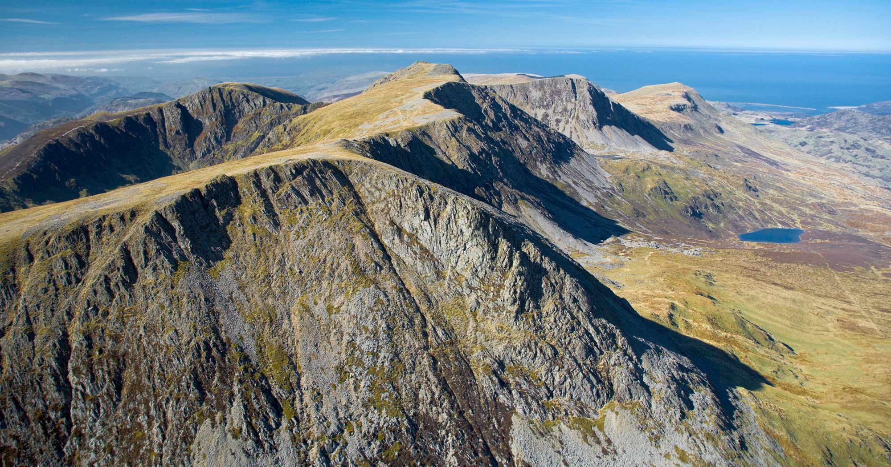

**Contents**

Introduction 2

Activities 2

Accommodation 3

Location and Local Area 3

Weather 3

Transport 3

Activities & Schedule 3

Personal Equipment 4

Leaders 4

Home Contact Details 5

Trip Cost 5

Spending Money 5

Payment Instalments 5

Application 5

**Trip Information and Permission Form**

**Mountain Activities and Biking in Wales: 10 November – 12 November 2017**

## Introduction

We are running our final trip of the year to Wales to do some mountain activities such as navigation and map interpretation and MAYBE we'll get to see the summit of Cader Idris weather permitting, but we’ll probably stay lower down. We're also planning a bike ride along the picturesque Mawddach estuary into Barmouth, the popular seaside town located on the west coast of Snowdonia. There is a long sandy beach and a pretty harbour but more importantly there is Knickerbockers – an amazing ice-cream parlour serving up a dizzying array of delicious ice cream and candy.

## ****Activities****

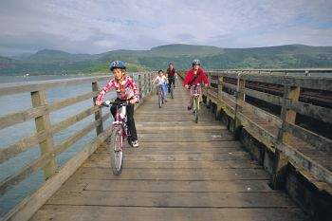This is our final outdoor weekend of the year where we can get **everyone** in the group out and about together doing great activities in stunning scenery.

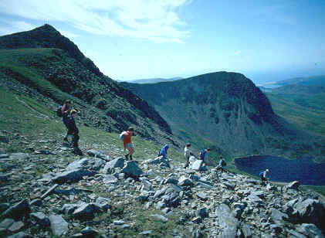We’ll potter around the lower slopes of Cader Idris, one of the highest mountains in Wales, testing our knowledge of map interpretation and practising our navigation skills. If the weather is kind to us we might even do the fabulous easy walk to the summit where we'll be able to see some consistent stunning views from the ascending ridge across the Barmouth estuary and up to Mt Snowdon in northern Snowdonia.

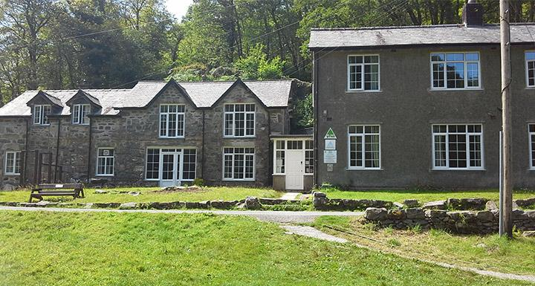On Friday and Saturday evening we will be staying at Kings Youth Hostel which nestles on the slopes of the Cader Idris mountain range and is set in its own wooded ravine. The hostel is the ideal base from which to summit Cader Idris and to walk, run or cycle the popular Mawddach estuary trail, both can be accessed directly from the hostel grounds.

On Saturday we will head onto Cader Idris with maps, compasses and a packed lunch for a day on the mountain. In the evening, after dinner, we'll visit Dolgellau to get a sense of this ancient Welsh county town of Gwynedd - its main bridge over the Afon Wnion dates back to 1638. There are some more modern features such as local hostelries serving tea and cakes which are well worth a visit too. The next day we will cycle part of the Mawddach trail starting at Dolgellau and finishing in glory at Knickerbockers in Barmouth. It might even be warm enough to dip a toe in the sea before we head back to Knowle.

The trip will take place the weekend of 10 – 12 November 2017. **This is an absolutely brilliant trip, read on!!!!**

## ****Accommodation****

We will be staying at Kings Youth Hostel (http://www.yha.org.uk/hostel/kings). It has all we need: showers, toilets, stunning views and not many people around! This 42 bed Youth Hostel has a selection of dorm rooms and private rooms, some of which are en-suite. There is no TV or mobile phone signal at the hostel, making YHA Kings a fantastic 'get away from it all' location.

## Location and Local Area

Kings Youth Hostel is in ‘the middle of nowhere’ in the foothills of one of the finest mountains in Wales - Cader Idris. It is located in Snowdonia National Park and may be a few hundred feet shorter than Snowdon but it has stunning views with a variety of paths to the summit through ancient oak woodlands, glacial valleys to wide open vistas. Five miles up the road is Dolgellau - a town that’s going places. Its go-ahead attitude is reflected in an ever-improving range of local events and festivals, outdoor activities and places to stay and eat. But Dolgellau’s natural resources remain its number-one asset. The handsome, dark-stoned market town is set beneath Cader Idris, the legendary ‘Chair of Idris’, on the approach to the beautiful Mawddach Estuary. 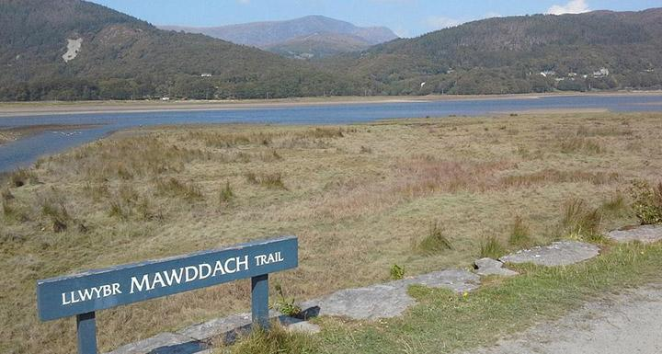

The Mawddach Trail forms part of Lôn Las Cymru (National Cycle Network Route 8) which runs from Holyhead to Cardiff and is one of the most scenic railway paths in the country, running along the spectacular and atmospheric Mawddach Estuary below the foothills of Cadair Idris. The trail follows the course of the old railway line from Barmouth to Ruabon which was open between 1869 and 1965 and was popular with Victorian holiday makers visiting the fashionable resort of Barmouth.

Barmouth is (geographically) one of the closest [seaside resorts](https://en.wikipedia.org/wiki/Seaside_resort) to the [West Midlands](https://en.wikipedia.org/wiki/West_Midlands_conurbation) and is located on the west coast of North Wales. It lies between a mountain range and the sea on the mouth of the river Mawddach and Cardigan Bay. It rests just within the south west corner of Snowdonia National Park and is steeped in a history rich with connections to the shipping and slate industries. The old town is well worth a visit with its steep steps and slate-roofed cottages and there is a long sandy beach for those hot summer days.

## Weather

The usual weather in November is cold! The usual temperature is around 7 degrees and it can be a bit rainy at that time of the year but with the proper gear and all the activities you’ll be doing you won’t notice. Temperatures can differ depending on where you are – the higher up the mountains you are the colder it is likely to be.

## Transport

We will be using cars to transport everyone with kit. All you have to do is turn up to Bickers on the Friday night and get in. We’ll get you there and back.

## Activities & Schedule:

The program for the trip is as follows:

|  |  |
| --- | --- |
| Date | Activity / Event |
| Friday 10 November 2017 | * Meet at Bickers at 5.30pm for departure to Wales. Trip duration: around 3 hours. (Please eat dinner beforehand) * We will stop off in Welshpool for a break and some Fish and Chips should anyone want some * Arrive at Kings Youth Hostel * Snack * Bed |
| Saturday 11 November 2017 | * Breakfast and out onto Cader Idris   + Maybe climb the ridge leading to the summit of Cader   + Mountain activities on the lower slopes of Cader * Evening Dinner * Trip into Dolgellau * Bed |
| Sunday June 23rd | * Pack up all equipment to vehicles * Travel to Dolgellau – the start of our morning cycle along the Mawddach trail to Barmouth * Quick visit to Barmouth for ice cream and dip a couple of toes in the sea at Barmouth beach * Everyone into vehicles to return home to Bickers for 6pm. |

## Personal Equipment:

We’re not sure what the weather will be like at this time of the year and there is always every potential for the forecast to change from hour to hour. However, some sensible equipment will be all that is needed to enjoy the trip in comfort. If the weather is cool you won’t be cold at all if you have the right equipment. A kit list is provided on the last page, but the important items are:

* Waterproofs: the weather can be pretty changeable at this time of year.
* Proper Walking boots are **essential**: you need to make sure you have boots, not cross trainers, shoes etc. You will need a good level of foot & ankle support. If you don’t have them you can get them at Oswald Bailey. Look for a boot with a good leather upper, or a water resistant soft outer. Don’t spend a fortune, but don’t skimp either!! We will check the footwear of trip attendees the week before.

The kit list is supplied at the end.

## Leaders

The leaders on this trip are as follows:

|  |  |  |  |
| --- | --- | --- | --- |
| ****Leader**** | | ****A little about them, in case you didn’t already know**** | |
| Simon Thomas | | | |
| Likes: Aston Villa, Curry, Muse concerts, offshore yachting & water skiing.  Dislikes: Fishing, Darts, Snooker Birmingham City, Bear Grylls, Westlife, queues, Halifax bank adverts  Age: about 12 | | Simon has been planning and running trips for youth groups for over 20 years. Simon has extensive mountain experience and is currently completing his Mountain Leader award. He’s a very smart fella! Having worked in the U.S. for 16 years, Simon was also a waterfront activities director at a kids' summer camp in Maine, USA. His favourite ocean is the Atlantic, his favourite lake is Round Pond and his favourite puddle was in Gloucester - he jumped in and it went right up to his middle...  **Interesting Fact:** Simon's walking boots are made from the skin of a polar bear he successfully wrestled in the Alaskan tundra. | |
| Lindsay Underwood | | |
| Likes: A good giggle, maps, skiing, pate and penguins  Dislikes: Tin cans without ring pulls, old boilers, pink flowery wallpaper and those knitted covers you can get to cover toilet rolls  Age: 44 | Lindsay is fast turning in to CAG’s very own Bearess Grylls, although not quite as annoying and full of…. She is CAG's best female skier and has recently danced the whole of Swan Lake on the summit of Ben Nevis (Pony track approach) wearing only a tutu, ballet shoes and crampons. Her other favourite pastime is lying in her hand knitted hammock which is strung between two horse chestnut trees she grew from conkers, googling cabbage recipes.  **Interesting Fact:** Lindsay is actually a descendant of native American parents and her spiritual name is Swimming with Otters | |
| Ruth Billingham | | |
| Likes: Gin, making up stories and GoT  Dislikes: Everything not gin, mussels, cheap tonic and caterpillars  Age: 21 | Ruth grows her own vegetables and has recently won a gold medal for growing the biggest cabbage in the history of the world. At six metres across and five metres high it is bigger than the infamous enormous turnip and can be seen from the ISS if it passes at the right angle. She will mostly be eating boiled cabbage, cabbage soup, cabbage curry, stir fried cabbage, cabbage jam, cabbage and custard and cabbage three ways for the next fifty years.  **Interesting Fact:** Ruth is attending elocution lessons in order to improve on her Brummie accent – it's bostin' bab! | |
| Richard Ackroyd | | |
| Likes: Teeth – he’s a dentist, Simon – like a god  Dislikes: The woman over the road from him, that’s about it.  Age: 24 | Richard is a former CAG member and has been a leader for a couple of years now.  Richard has worked as a dentist for a year and is already going back to Uni to learn some more – or he’s not very good. Richard is commonly known as “Dickie” and coming on the CAG ski trip in 2018. He is also a very experienced expeditioner.  **Interesting Fact:** Richard has successfully converted a Skoda Fabia from what was once an ordinary budget family car, into one of immense lack of power, cleaning and comfort. | |
| Stuart Knight | | |
| Likes: Bear Grylls, Canoeing, Walking, Beer.  Dislikes: Skiing quickly, Channel 5.  Age: 24 | Stuart has been with CAG as a parent leader and now a normal leader for many years. His first, of many expedition to CAG’s Shropshire base, has become legendary in how not to climb Brown Clee. Stuart is a keen skier, is coming on the CAG ski trip in 2018 and will be firmly put in his place about his skiing ability.  **Interesting Fact:** Not many people know this, but Stuart has absolutely nothing to do with any Knight of any kind – it’s just his name. | |

## Home Contact Details

To be confirmed.

## Trip Cost

This is a subsidised trip after a grant from fund givers. Therefore the trip cost has been reduced to £75.

## Spending Money

We will stop for fish and chips on the way to Wales and will get ice cream and sticks of rock in Barmouth - £10 - £15 will be more than sufficient. If you need us to keep this safe for you we will put it in an envelope and hold on to it for you.

## Payment Instalments

In order to spread the cost we will operate the following payment plan:

* Initial payment with application **by 26 September 2017 - £40**
* Final payment to be received by 24 October 2017 - £35

All payments are to be sent online - electronically (no cash or cheques please) to:

* Sort code: 402622
* Account: 41271806
* Payment reference: son’s name and “Kings"

If you wish to pay in one instalment in advance, please do so, we won’t stop you.

## Application

To apply to go on the trip please return your form to:

**Ruth Billingham  
1603 Warwick Road  
Knowle  
Solihull  
West Midlands  
B93 9LF**

**Please return your form to the address above by 26th September!! If you want to bring your forms to a meeting night please do so. If you want to bring them back as soon as possible, please do, that will really help!**

If you can’t return your forms by that time please email [simon@challengeadventure.org](mailto:simon@challengeadventure.org) to notify him of your intention to take part.

**Intention to Participate:**

**Mountain Activities and Biking in Wales**

|  |  |
| --- | --- |
| **Parent / Guardian name:** |  |
| **Name of CAG member intending to take part in the trip:** |  |
| I understand the cost of the trip will be £75  I understand the trip will run from the dates of 10 – 12 November 2017. I enclose the trip deposit or full fee (non-refundable in the case of acceptance on the trip) payable to “Challenge Adventure Group”. | |
| I understand the deadline for application and payment of a deposit or the full fee will be Tuesday 26 September 2017.  I understand the balance payment of £35 is required by Tuesday 24 October. If I don’t complete the payment by that date I understand my son’s place may be offered to another CAG member. | |
| By signing this form I confirm that the above named CAG member will take part in the trip and I will be liable for the full cost of the trip, unless otherwise notified by the leader in charge, in the event that my son will not be able to take part for whatever reason. | |
| **Signed:** |  |
| **Date:** |  |
|  |  |
|  |  |

**Permission and Health Form:**

**Mountain Activities and Biking in Wales**

To be signed by a parent / guardian. Please complete legibly in black ink.

Please return this form signed and dated by Tuesday 26 September 2017to Ruth Billingham at: **1603 Warwick Road, Knowle, Solihull, B93 9LF or the next meeting.**

|  |  |
| --- | --- |
| The trip will take place at:  **Kings Youth Hostel, Gwynedd, Wales, LL40 1TB, Cader Idris, Dolgellau and Barmouth.** | The trip will take place on 10 – 12 November 2017.  We are leaving from Bickenhill on 10 November 2017 at 5.30pm and will return at 5.30pm on 12 November 2017.  The cost of the trip is **£75**. |
| No responsibility for the personal equipment / clothing and effects can be accepted by the camp organisers and Challenge Adventure Group does not provide automatic insurance cover in respect to such items. | |
| I give permission for  to attend the Mountain Activities and Biking in Wales Trip on 10 – 12 November 2017.  Has he been in contact with any infectious diseases within the last three weeks:   |  |  |  |  |  | | --- | --- | --- | --- | --- | |  | Yes | |  | No | | Date of last tetanus immunisation: | | | ______ / __________ / _______ | | |   Medicines currently being taken:  Does he have any allergies to food, medicines or other? Please provide details.  Does he have any special dietary needs? Please provide details. | Does he have any special needs? Please continue overleaf if necessary.  Does he have any conditions that may prevent him from taking part in the programmed activities?   |  |  |  |  | | --- | --- | --- | --- | |  | Yes |  | No |   If so, please provide details below. Please continue overleaf if necessary.  Name and address of own doctor:   |  |  | | --- | --- | | Date of birth: | ________ / __________ / _________ |   During the event I can be contacted in an emergency at:   |  |  | | --- | --- | | Address: |  | | Telephone number: |  | | Mobile Number: |  | |

I understand that the Leader reserves the right to send any participants home if necessary and that I may be requested to pick up my child from any location on the trip. If it becomes necessary for my child to receive medical treatment and I cannot be contacted by telephone or any other means to authorise this, I hereby give my general consent to any necessary medical treatment and authorise the leader in charge of the trip to sign any document required by the hospital authorities.

|  |  |  |  |
| --- | --- | --- | --- |
| **Signed:** |  | **Date:** |  |

Note: The medical profession takes the view that the parent’s consent to medical treatment cannot be delegated. This view is explicit in the Children Act 1989. Thus medical consent forms have no legal status and a doctor/nurse insisting on the consent of a parent to a particular treatment has the right to do so.

**Kit List:**

**Hiking and Biking in Wales**

You will need the following:

* Walking boots – not walking trainers
* Waterproofs - do not forget them
* Plenty of thin layers

The following list is a minimum that you must bring.

**You must have WATERPROOFS**. That doesn’t mean ‘showerproof’, but WATERPROOF. If you need to get equipment, some suggestions for you:

* Go to Millets in Solihull – they will give you 10% discount if you mention you are with Challenge Adventure Group (ask them to put it down as a scout discount if they look confused).

|  |  |
| --- | --- |
| **Required!!**   * Walking boots and walking boot socks * Wicking undershirt * Lightweight trousers * Underwear x 2 * Socks x 2 * T shirts x 2 * Fleece pullover / jacket (not sweatshirt!!) * Warm Jacket * Gloves and hat * Water bottle * Spare plastic bags for dirty / wet clothes * Personal First Aid Kit * Waterproof Jacket * Waterproof Trousers * Towel | **Optional**   * Thermal underclothing: top and bottom * Playing Cards * Camera * A full washkit – will it be used? If not - don’t bother.   **Do NOT bring:**   * A knife of any kind – you won’t need it and we’ll take it off you! * Mobile Phone!!!!!! There’s no signal there, really, there ISN’T!!. * Ipod or other music player if you don’t want to damage it – if you do it will be your responsibility. |

**Cotton Clothing**

**Cotton clothing will pick up moisture very quickly and won’t dry in the conditions we will be in**. Please make sure that you don’t bring cotton clothing if you can – that includes jeans. If you don’t know if an item is cotton or not please check the label. Most hoodies / sweat shirts have a high cotton content.

**Naming Items:**

Please make sure all of your items are suitably marked or named so that you can reclaim them. We always have items of clothing left over that probably amount to over £100. If they are named we will be able to get them back to you. Call Simon on 07808 481688 if you have any questions.